Readme task 3
SWYNEX – Interactive Dashboard (Task 3)
An interactive dashboard that communicates the main findings from the YouTube Trending Videos (US) analysis completed in Tasks 1 and 2. It is a single, self-contained web page (HTML, CSS and JavaScript) that opens in any browser, works offline and needs no installation.

Dashboard preview:

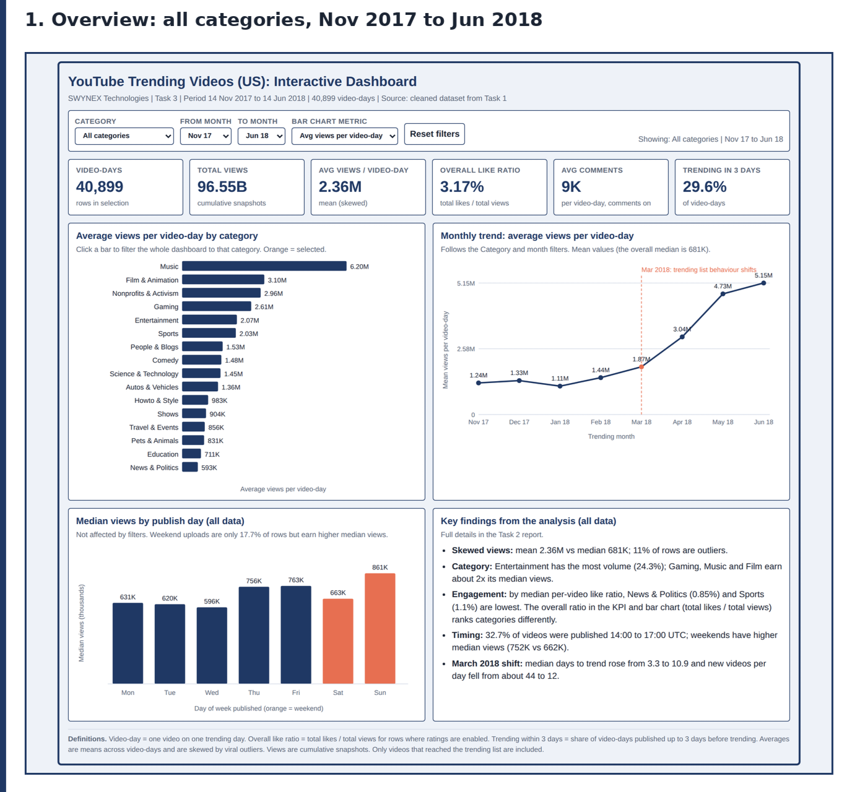
Default view: all categories, Nov 2017 to Jun 2018.

Objective
Build a professional dashboard from the analysed dataset, with KPIs, charts and useful filters, that clearly communicates the main findings (Task 3 of the SWYNEX Data Analytics internship).

Dashboard features
Filters
Filter What it does
Category Shows one of the 16 YouTube categories, or all
From month / To month Limits the period (Nov 2017 to Jun 2018)
Bar chart metric Switches the category chart between average views, video-days and like ratio
Click a bar Clicking a category in the bar chart applies it as the Category filter
Reset filters Returns to the full dataset
KPI cards
KPI Definition
Video-days Number of rows: one video on one trending day
Total views Sum of views across the selected rows (cumulative snapshots)
Avg views / video-day Mean views per row (skewed by viral videos)
Overall like ratio Total likes ÷ total views, for rows where ratings are enabled
Avg comments Mean comment count per row, for rows where comments are enabled
Trending in 3 days Share of rows published up to 3 days before trending
Charts
Chart Responds to filters? Purpose
Category bar chart Month range (and highlights the selected category) Compare reach, volume and engagement by category
Monthly trend line Yes Shows the shift in average views, annotated at March 2018
Median views by publish day No (full data) Shows weekend uploads earn higher median views
Key findings panel No (full data) Five headline findings from the Task 2 analysis
Main findings communicated
Views are heavily skewed: the mean (2.36M) is 3.5 times the median (681K).
Entertainment has the most volume (24.3%), but Gaming, Music and Film & Animation earn about twice its median views.
News & Politics (0.85%) and Sports (1.1%) have the lowest median per-video like ratios.
Weekend uploads are only 17.7% of trending rows but have higher median views (752K vs 662K).
The trending list changed around March 2018: median days to trend rose from 3.3 to 10.9, and new videos entering the list per day fell from about 44 to 12.
Interactive views (screenshots)
1. Filter by category and period: Music, March to June 2018. All six KPI cards and the monthly trend update instantly.

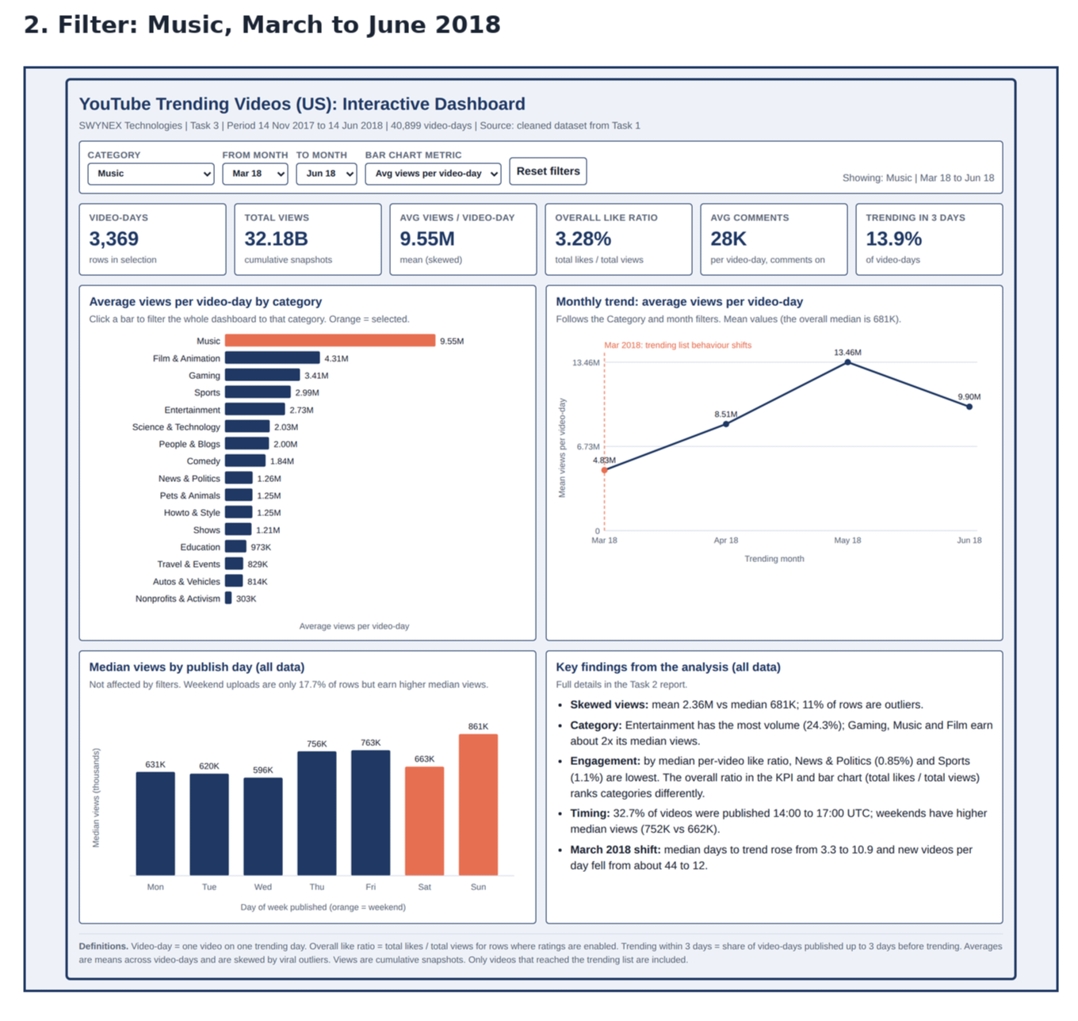
Music, Mar to Jun 2018

2. Change the bar chart metric: overall like ratio by category, showing engagement instead of reach.

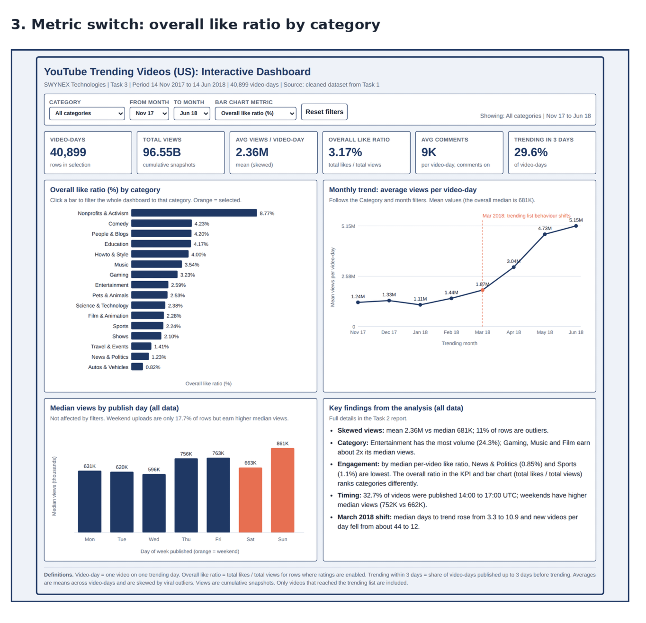
Like ratio by category

3. Click a bar to drill into one category: News & Politics, all months.

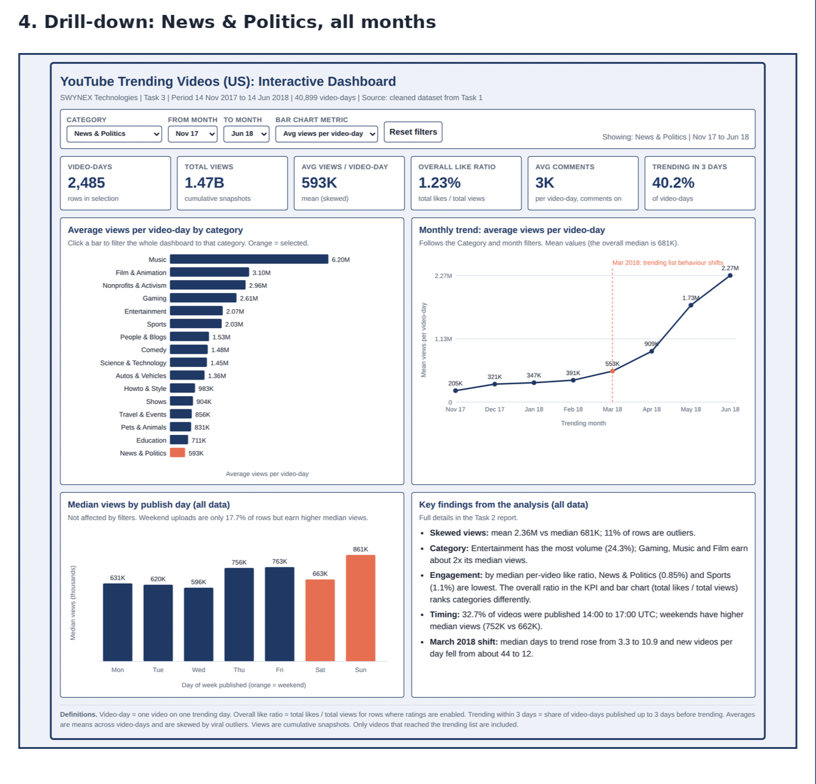
News & Politics

Note on like ratio: the dashboard KPI and bar chart show the overall like ratio (total likes ÷ total views). The finding quoted above uses the median per-video like ratio from the Task 2 analysis. The two measures rank categories differently: by median per video, News & Politics (0.85%) and Sports (1.08%) are lowest; by overall ratio, Autos & Vehicles (0.82%) and News & Politics (1.23%) are lowest, and Sports is 2.24%.

How to use
Download or clone the repository and open index.html in a browser.
Pick a category and a month range, or click a bar in the category chart.
Read the KPI cards and charts, which update instantly.
Click Reset filters to go back to the full view.
Repository structure
README.md
index.html the dashboard
screenshots/ 4 dashboard screenshots used in this README
data/youtube_trending_us_cleaned.csv cleaned dataset from Task 1 (source data)
Publish it with GitHub Pages (optional)
Repository Settings → Pages → deploy from the main branch, root folder. GitHub will give you a link to the live dashboard.

How it was built
Source: the cleaned dataset from Task 1 (40,899 rows, 6,351 videos, 16 categories, 14 Nov 2017 to 14 Jun 2018).
Preparation: the data was aggregated by category and month (video-days, views, likes, comments and videos trending within 3 days) in Python (pandas) and embedded in index.html, so the page loads instantly and works offline.
Visuals: hand-built SVG charts with JavaScript; no external libraries or internet connection are required.
Design: bordered panels, labelled axes, data labels, definitions footer, and light and dark mode support.
Validation
Dashboard figures were checked against the source CSV. For example, Music from March to June 2018 shows 3,369 video-days, 32.18B total views and 9.55M average views per video-day, matching the dataset. The page was also tested in a headless browser with no errors.

Notes and limitations
Averages are means and are pulled up by viral videos; medians are in the Task 2 report.
Likes and comments are blank when ratings or comments are disabled, so those rows are excluded from like ratio and average comments.
Views are cumulative snapshots on each trending day, not daily views.
Only videos that reached the trending list are included, so the results do not describe YouTube overall.
US data only; June 2018 covers 14 days.
Built as an HTML dashboard rather than in Power BI or Tableau, which the task allows ("another suitable BI tool").
Related tasks
Task 1: Data Cleaning and Preparation
Task 2: Exploratory Data Analysis
Author
Gautam Kurpatwar · GitHub: GK3210 · LinkedIn: (https://www.linkedin.com/in/gautam-kurpatwar-98268138a?utm_source=share_via&utm_content=profile&utm_medium=member_android)

Completed as part of the Data Analytics internship at SWYNEX Technologies.

#SWYNEX #Internship #DataAnalytics #Dashboard #Python

